

**A SYNOPSIS OF PROJECT**

**ON**

Online Grocery Store Management

**Submitted By**

## Esha Ravindra Mandavkar Nazrana Hamid Kurawle Onkar Rajan Malawade

**Submitted To**

**DEPARTMENT OF MCA**

# FINOLEX ACADEMY OF MANAGEMENT AND TECHNOLOGY, RATNAGIRI



**A PROJECT REPORT ON**

# Online Grocery Store Management

**Submitted in partial fulfillment for Degree of**

MASTER OF COMPUTER APPLICATION

**By**

**Esha Ravindra Mandavkar Nazrana Hamid Kurawle Onkar Rajan Malawade**

**Under the guidance of**

**Prof. Waman R. Parulekar (Department of MCA)**

**Submitted to**

**Department of MCA**

**FINOLEX ACADEMY OF MANAGEMENT AND TECHNOLOGY, RATNAGIRI**



### FINOLEX ACADEMY OF MANAGEMENT AND TECHNOLOGY, RATNAGIRI

**This is to certify that the project report titled:**

## Online Grocery Store Management

**Submitted By:**

## Esha Ravindra Mandavkar Nazrana Hamid Kurawle Onkar Rajan Malawade

#### In partial fulfillment of the award for degree of

**MASTER OF COMPUTER APPLICATION**

**From Mumbai University**

**And are the bonafide records of the work done by them during the Semester I of**

**A.Y 2023-2024**

|  |  |  |
| --- | --- | --- |
| **Internal Guide** | **HOD** | **Principal** |
| **(Prof. Waman R. Parulekar)** | **(Prof. Tejas V. Joshi)** | **(Dr. Kaushal K. Prasad)** |

### ABSTRACT

This abstract introduces an Online Grocery Store Management System designed to enhance operational efficiency. The system features intuitive customer interfaces, real-time inventory management, secure order processing, personalized customer engagement, and robust logistics.

The goal is to streamline online grocery operations, optimize inventory, ensure secure transactions, and elevate the overall shopping experience. This system represents a significant advancement in addressing the evolving needs of virtual grocery stores and contributes to the growth of the online grocery retail sector.

With secure payment gateways, real-time tracking, and robust security protocols, the system aims to provide a seamless and secure online grocery shopping experience. Emphasizing the integration of cutting-edge technologies, this system is poised to elevate the performance and customer satisfaction of virtual grocery stores.

### ACKNOWLEDGEMENT

I wish to express my sincere thanks to The Principal Dr. P. P. Kulkarni, Vice Principal Dr. A. M. Kulkarni, HOD of Department of Master of Computer Applications Mr. Tejas V. Joshi for their support and for the facilities they have made available. I would also like to express my sincere gratitude to everyone for supporting me throughout my team project. First, I will thank my guides, Mr. Waman Parulekar for their enthusiasm, patience, insightful comments, helpful information, practical advice and unceasing ideas that have helped me tremendously at all times.

I am also grateful to the staff of Department of Master of Computer Applications for their consistent support and assistance. Finally, last but by no means least; I would thank my parents for their guidance and support on every step of mine, also to everyone in the Department of Computer Applications, it was great sharing premises with all of you during last 6 Months. Thanks for all your encouragement.

**TABLE OF CONTENT**

|  |  |  |
| --- | --- | --- |
| Sr no | Content | Page No |
| **1** | **Introduction** | 1 |
|  | 1.1 Background | 1 |
|  | 1.2 Objectives | 1 |
|  | 1.3 Purpose, Scope and Applicability | 2 |
| **2.** | **Survey Of Technologies** | 3 |
|  | 2.1 Existing Systems and its Limitations | 3 |
|  | 2.2 Proposed System | 4 |
| **3.** | **Requirements and Analysis** | 6 |
|  | 3.1 Requirement Specifications | 6 |
|  | 3.2 Planning And Scheduling – Gantt Chart | 7 |
|  | 3.3 Hardware Requirements | 8 |
|  | 3.4 Software Requirements | 8 |
|  | 3.5 Preliminary Product Description | 9 |
|  | 3.6 ER And UML Diagrams | 12 |
| **4.** | **System Design** | 18 |
|  | 4.1 Modules | 24 |
|  | 4.2 Data Design | 26 |
|  | 4.3 User Interface Design | 30 |
|  | 4.4 Test Cases Design | 35 |
| **5.** | **Conclusion** | 36 |
| **6.** | **Bibliography** | 37 |

## INTRODUCTION

#### Background:

The global shift towards digitalization has revolutionized the way consumers engage with businesses, particularly in the retail sector. The advent of online shopping has significantly impacted the grocery industry, prompting a surge in virtual platforms that offer customers the convenience of purchasing groceries from the comfort of their homes.

This paradigm shift necessitates a sophisticated management system tailored to the unique challenges and opportunities posed by the online grocery retail space.

#### Objectives:

The primary objectives of the Online Grocery Store Management system are to streamline and optimize various facets of virtual grocery store operations. This includes but is not limited to, efficient inventory management, seamless order processing, enhanced customer engagement, secure transactions, and effective logistics management.

By addressing these objectives, the system aims to elevate the overall efficiency, profitability, and customer satisfaction levels of online grocery businesses.

#### Purpose, Scope and Applicability:

**Purpose:**

The purpose of implementing this management system is to respond proactively to the evolving dynamics of the grocery retail landscape. With an increasing number of consumers turning to online platforms for their grocery needs, there is a pressing need for a comprehensive solution that can manage the intricacies of virtual stores.

The system is designed to offer a user-friendly and secure environment for customers while providing grocery retailers with the tools necessary to optimize their operations and stay competitive in the digital marketplace.

#### Scope:

The scope of the Online Grocery Store Management system encompasses a wide range of functionalities. It covers inventory management to ensure accurate tracking and timely replenishment, efficient order processing to facilitate a smooth transaction process, personalized customer engagement tools for an enhanced shopping experience, and robust logistics management to guarantee timely and accurate deliveries.

The system's scalability allows it to adapt to the evolving needs of both small-scale local online grocers and large, established virtual supermarket chains.

#### Applicability:

This management system is applicable to a diverse range of online grocery businesses, irrespective of their scale or geographic location. From startups venturing into the e-commerce space to well-established retailers looking to enhance their digital presence, the system's flexibility and adaptability make it suitable for a broad spectrum of applications.

Its modular design allows businesses to tailor the system according to their specific requirements, ensuring relevance and effectiveness across the online grocery retail sector.

### SURVEY OF TECHNOLOGIES

#### Existing System:

Traditionally, grocery shopping was predominantly a brick-and-mortar experience, with customers physically visiting stores to select and purchase their items. With the advent of the internet, online grocery shopping platforms emerged, offering a convenient alternative to traditional shopping. However, the existing systems still exhibit several limitations.

#### Limitations:

1. Manual Inventory Management: Inaccuracies and delays.
2. Slow Order Processing: Delays in confirming and fulfilling orders.
3. Limited Customer Engagement: Basic interfaces lacking personalization.
4. Inefficient Logistics: Suboptimal route planning and delivery delays.
5. Security Concerns: Vulnerabilities risking data breaches.
6. Limited Scalability: Struggles with growth and expanding into new markets.
7. Lack of Real-time Analytics: Inability to make data-driven decisions promptly.
8. Resistance to Change: Reluctance to embrace technological advancements.
9. Addressing these limitations is crucial for enhancing efficiency and customer satisfaction in the online grocery retail space.

#### Proposed System

The proposed Online Grocery Store Management System aims to address the limitations of the existing system by introducing innovative features and advanced technologies. Key components of the proposed system include:

##### Automated Inventory Management:

Utilize advanced inventory management systems with real-time tracking and automated replenishment to prevent stockouts and overstock situations.

##### Efficient Order Processing:

Implement streamlined and automated order processing mechanisms, reducing processing times and enhancing overall efficiency.Integrate secure and seamless payment gateways for smooth transactions.

##### Personalized Customer Engagement:

Develop a user-friendly interface with personalized recommendations and loyalty programs to enhance customer engagement and satisfaction.

##### Optimized Logistics:

Integrate intelligent logistics management systems with route optimization, real-time tracking, and dynamic scheduling for timely and efficient deliveries.

##### Enhanced Security Measures:

Implement robust security protocols, including encryption and secure authentication, to safeguard customer data and ensure secure online transactions.

##### Scalability and Adaptability:

Design the system to be scalable, accommodating growth in transaction volume and expanding seamlessly into new markets.

##### Real-time Analytics and Reporting:

Incorporate data analytics tools for real-time insights into customer behavior, market trends, and operational performance, facilitating data-driven decision-making.

##### User-Friendly Interface:

Develop an intuitive and responsive user interface, ensuring a seamless and enjoyable online shopping experience for customers.

##### Integration with Emerging Technologies:

Explore the integration of emerging technologies such as artificial intelligence and machine learning to enhance system intelligence and automation.

##### Continuous Innovation and Adaptation:

Establish a framework for continuous innovation, regularly updating the system to adapt to evolving consumer trends and technological advancements.

**The proposed system aims to revolutionize online grocery store management, providing a more efficient, secure, and customer centric platform. By addressing the shortcomings of the existing system, it strives to elevate the overall online grocery shopping experience and contribute to the growth of the digital grocery retail sector.**

### REQUIREMENTS AND ANALYSIS

#### Project Definition:

This project aims to develop an Online Grocery Store Management System, leveraging cutting- edge technologies to streamline inventory management, enhance order processing, and optimize logistics. Key objectives include automated inventory tracking, efficient order confirmation, personalized customer engagement, and robust security measures.

The system will be scalable and adaptable, catering to various store sizes and geographic markets. The project will follow an agile development methodology, ensuring flexibility and responsiveness to evolving requirements.

Deliverable include a fully functional system and comprehensive documentation. The expected impact is improved operational efficiency, increased customer satisfaction, and a positive contribution to the growth of the online grocery retail sector.

# Work Breakdown Structure of Our Project

**GANTT CHART**

**Preliminary Investigation**

Proposed Time Actual Time

**System Analysis**

**System Design**

**System Coding**

**Testing & Validation**

**Report Generation & Submission**

7

**A u g S e p t O c t N o v D e c**

#### 3.4 Software and Hardware Requirements

##### Software Used:

Front end: Microsoft Visual Studio 2019. Back end: Microsoft SQL Server 2008 R2 Operating System: Windows 8 or above.

Web Browser: Google Chrome, Mozilla Firefox, Microsoft Edge.

##### Hardware Used:

Processor: Intel Core i5 Memory: 4 GB RAM

Storage: Minimum 5GB of Hard disk Space.

##### Tools Used:

Report Viewer

STAR UML Diagram Tool WPS Office

#### 3.5 Project Description:

##### User Module:

* + The user module will cater to end-users who want to purchase groceries online.
  + Users can register and log in securely to access the system.
  + An intuitive interface will allow users to browse a variety of grocery products, add them to their shopping cart, and proceed to checkout.
  + The system will incorporate secure payment processing.

##### Admin Module:

* + The admin module will be accessible only to authorized personnel.
  + Admins can log in securely to the admin dashboard.
  + The dashboard will allow admins to manage the product inventory by adding new items, removing outdated products, and updating existing product information.

##### PRELIMANARY PRODUCT DESCRIPTION

Event table is a list of events of a system in rows and information about each event like.

1. **Trigger –** An occurrence that initiates the event which is either the arrival of data or of a point in time.
2. **Source –** An external agent or actor that supplies data to the System. **3] Activity –** Behavior of the system due to the occurrence of the event. **4] Response –** An output produced by the system as a result of the event.

**5] Destination –** An external agent or actor that receives the response generated by the system.

|  |  |  |  |  |  |
| --- | --- | --- | --- | --- | --- |
| **Event** | **Trigger** | **Source** | **Activity** | **Response** | **Destination** |
| Online Grocery store login page | Access to homepage | Manager | Access / use Homepage | Access to Web Pages | Website / Portal |
| User Registration | User Details | User | Access the Log DB | Accept Information | Online Gorcery Portal Store Portal |
| User Login | Access the page | User | Access the  Data Information | Access the Web page | User Page |
| User check  Products | Access the  Web page | User | Take Data  Information | Check Product  Data | Products Page |
| User give Feedback | Make Report | User | Generate Report | Give us  Reviews, Reports | User page |
| Admin update Product | Access the Books | User / Publisher | Add Products | Update Stocks Data Base | Data Base Server |
| User Buy | Access The Stock | User | Update Cart | Manipulate Data | Data server |
| User logout from web page | Leave the Web Page | User / Manager | Session Expired | Logout From Web page | Online Grocery Store Management |

##### Conceptual Model

**Submit/Register me/Add:**

By clicking this button data is stored on server and all the controls get refreshed and cleared. Then it will be ready for new record.

##### Clear/Back/Cancel:

By clicking this button all the controls get refreshed and cleared. Then it will be ready for next record to enter.

##### Login:

Used for logging in to particular account.

##### Search:

Used for logging in to particular account.

##### First/Next/Previous/Last:

Navigate to first/next/previous/last record in the particular form

##### Update/save changes:

This button is used to update the records/profiles.

##### Delete:

Admin can delete data and user can delete its account by clicking this button.

##### Pre-Flow Charts & System Flow Charts

Following symbols used to draw system flowchart :-

1. Used for process
2. Used for predefined process
3. Used for documents
4. Used for manual operation
5.  Used for online storage
6.  Disk or direct access file
7. Used for manual input
8. Used for display

User

Update Cart

Update Records

LOGIN

Add to Cart

Get Products

End

#### Entity Relationship Diagram :-

An entity relationship diagram (ERD) shows the relationships of entity sets stored in a database. An entity in this context is a component of data. In other words, ER diagrams illustrate the logical structure of databases.

##### Common Entity Relationship Diagram Symbols

An ER diagram is a means of visualizing how the information a system produces is related.

There are five main components of an ERD:

* 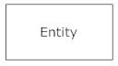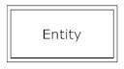**Entities**, which are represented by rectangles. An entity is an object or Concept about which you want to store information.
* 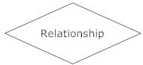**Actions**, which are represented by diamond shapes, show how two Entities share information in the database.
  + **Attributes**, which are represented by ovals. A key attribute is the unique, distinguishing characteristic of the entity. For example, an employee's social security number might be the employee's key attribute.

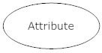

* **Connecting lines**, solid lines that connect attributes to show the relationships of entities in the diagram.
* **Cardinality** specifies how many instances of an entity relate to one instance of another entity.

##### Entity Relationship Diagram :-

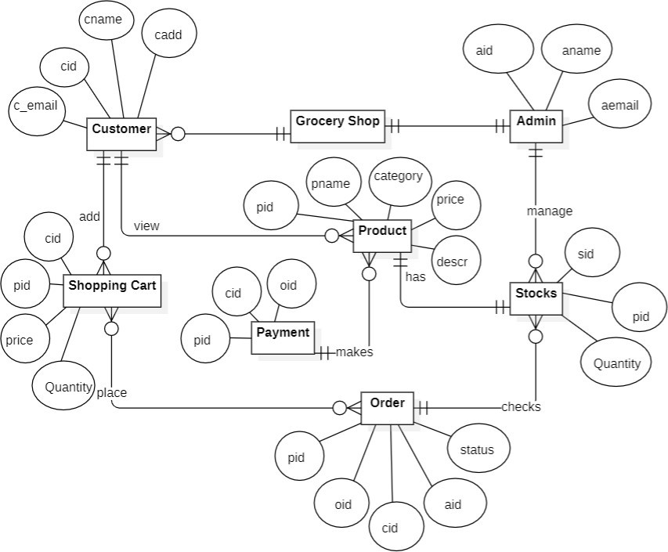

**Class Diagram :-**

A class diagram models the static structure of a system. It shows relationships between classes, objects, attributes, and operations.

##### Basic Class Diagram Symbols and Notations :-

**Classes**

Classes represent an abstraction of entities with common characteristics. Associations represent the relationships between classes.

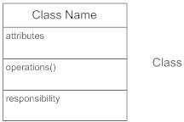

##### Active Classes

Active classes initiate and control the flow of activity, while passive classes store data and serve other classes. Illustrate active classes with a thicker border.

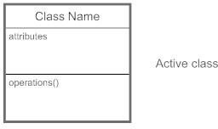

##### Visibility

Use visibility markers to signify who can access the information contained within a class.

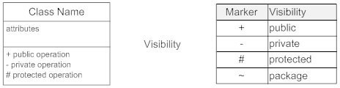

##### Associations

Associations represent static relationships between classes. Place association names above, on, or below the association line.

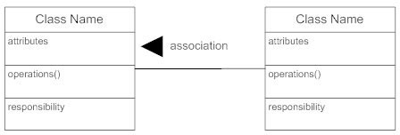

##### Multiplicity (Cardinality)

Place multiplicity notations near the ends of an association.

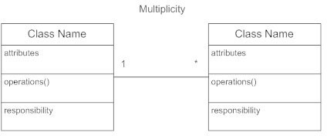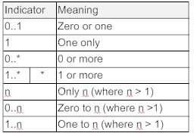

##### Constraint

Place constraints inside curly braces {}.

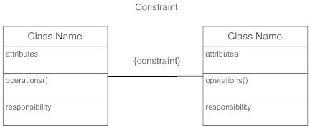

##### Class Diagram:

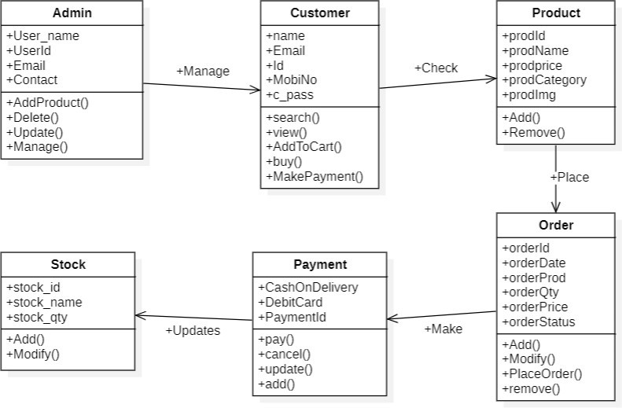

**Use Case Diagram: -**

A UML use case diagram is the primary form of system/software requirements for a new software program under developed. Use cases specify the expected behavior (what), and not the exact method of making it happen (how).

Use cases once specified can be denoted both textual and visual representation (such as UML). A key concept of use case modeling is that it helps us design a system from end user's perspective. It is an effective technique for communicating system behavior in the user's terms by specifying all externally visible system behavior.

**Purpose of Use Case Diagram**

Use case diagrams are typically develop in early stage of development and people often apply use case modelling for the following purposes:

* + Specify the context of a system
  + Capture the requirements of a system
  + Validate a systems architecture
  + Drive implementation and generate test cases
  + Developed by analysts together with domain experts

**Actor**



* + Someone interacts with use case (system function).
  + Named by noun.
  + Actor plays a role in the business
  + Similar to the concept of user, but a user can play different roles
  + For example:

A prof. can be instructor and also researcher plays 2 roles with two systems

* + Actor triggers use case(s).
  + Actor has responsibility toward the system (inputs), and Actor have expectations from the system (outputs).

**Use Case:**

Use case

* + System function (process - automated or manual)
  + Named by verb + Noun (or Noun Phrase).
  + i.e. Do something
  + Each Actor must be linked to a use case, while some use cases may not be linked to actors.

**Communication Link:**

The participation of an actor in a use case is shown by connecting a actor to a use case by a solid link.

Actors may be connected to use cases by associations, indicating that the actor and the use case communicate with one another using messages.

**Boundary of system:**

System

The system boundary is potentially the entire system as defined in the requirements document. For large and complex systems, each modules may be the system boundary. or example, for an ERP system for an organization, each of the modules such as personal, payroll, accounting, etc.

##### Use Case Diagram:

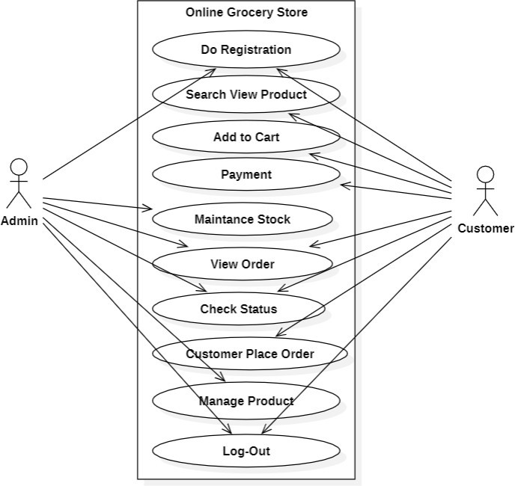

**Activity Diagram :-**

An activity diagram visually presents a series of actions or flow of control in a system similar to a flowchart or a data flow diagram.

##### Basic Activity Diagram Notations and Symbols:

**Initial State or Start Point:**

A small filled circle followed by an arrow represents the initial action state or the start point for any activity diagram. For activity diagram using swim lanes, make sure the start point is placed in the top left corner of the first column.



##### Activity or Action State:

An action state represents the non-interruptible action of objects. You can draw an action state in Smart Draw using a rectangle with rounded corners.

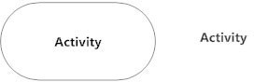

##### Action Flow:

Action flows, also called edges and paths, illustrate the transitions from one action state to another. They are usually drawn with an arrowed line.



##### Object Flow:

Object flow refers to the creation and modification of objects by activities.

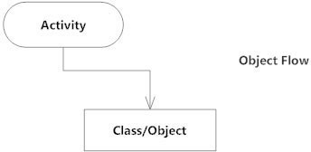

##### Decisions and Branching:

A diamond represents a decision with alternate paths. When an activity requires a decision prior to moving on to the next activity, add a diamond between the two activities.



##### Guards:

In UML, guards are a statement written next to a decision diamond that must be true before moving next to the next activity.

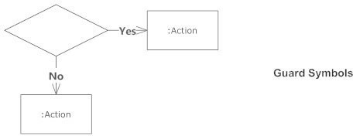

##### Synchronization:

A fork node is used to split a single incoming flow into multiple concurrent flows. It is represented as a straight, slightly thicker line in an activity diagram. A join node joins multiple concurrent flows back into a single outgoing flow.

A fork and join mode used together are often referred to as synchronization.

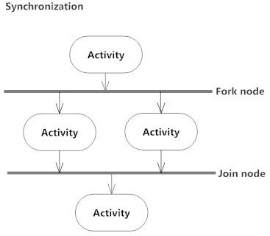

##### Final State or End Point:

An arrow pointing to a filled circle nested inside another circle represents the final action state.



##### Activity Diagram: -

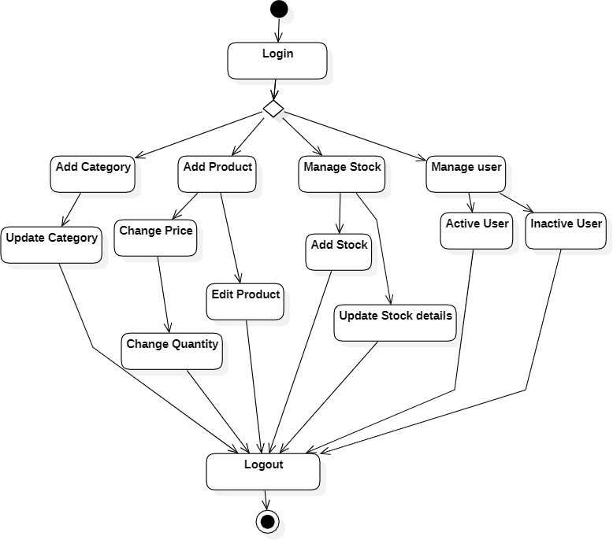

**Basic Modules:**

### SYSTEM DESIGN

Online Store Management System provides the module like: Manager

User

##### Manager:

In this module, manager can inputs record about books or user and publisher . Manager can modify records and viewing changed record. Manager can login systems and handled the web pages.



Log In

Handled the web page

Update and Modify

View details about

#### User:

In this module, customer or users can access system and customer first register and input records.

These records will be stored in database. Manager provide services via webpage to customer. Customer purchase or download or upload the books and make Editor page.

Customer

Login



View Product details

Verify Cart details

Buy it

##### 4.2 Schema Design

Registration

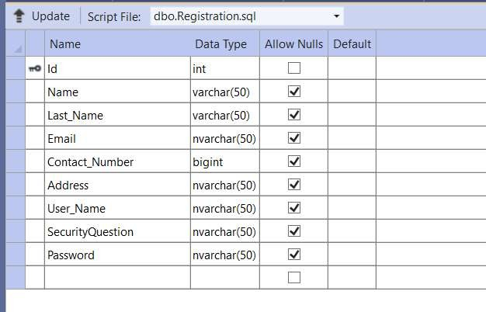

AdminLogin

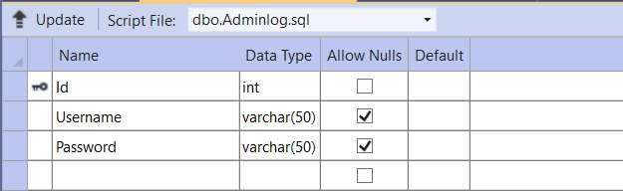

Product

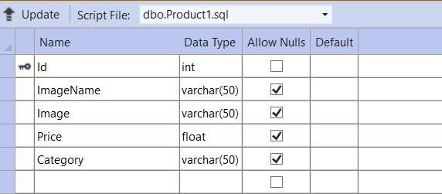

Order

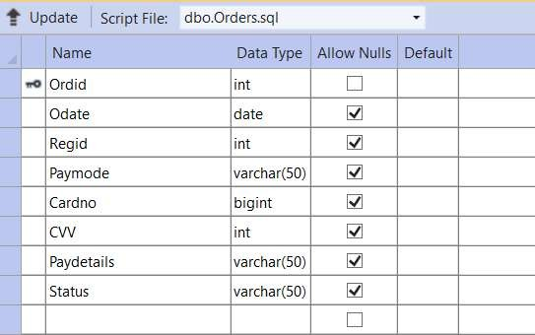

Order Details

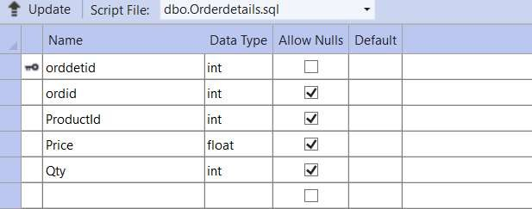

Cart

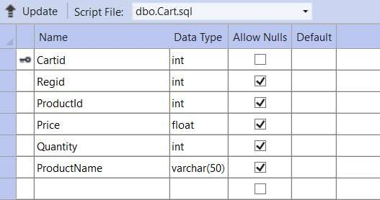

**4.3 Structural Overview of Our Web Site Home page**

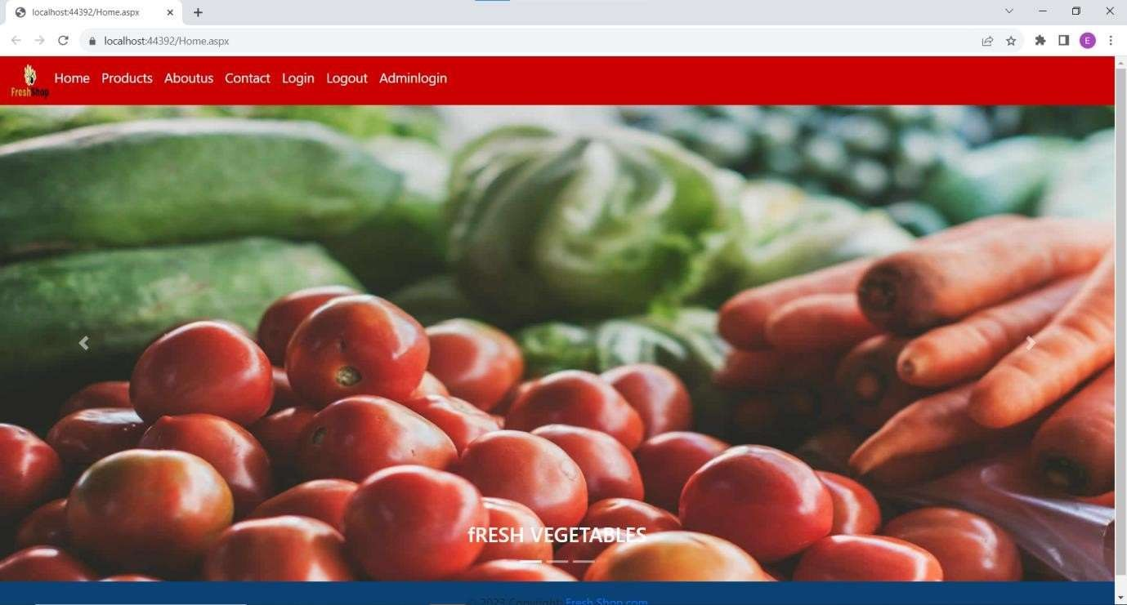

**User login**

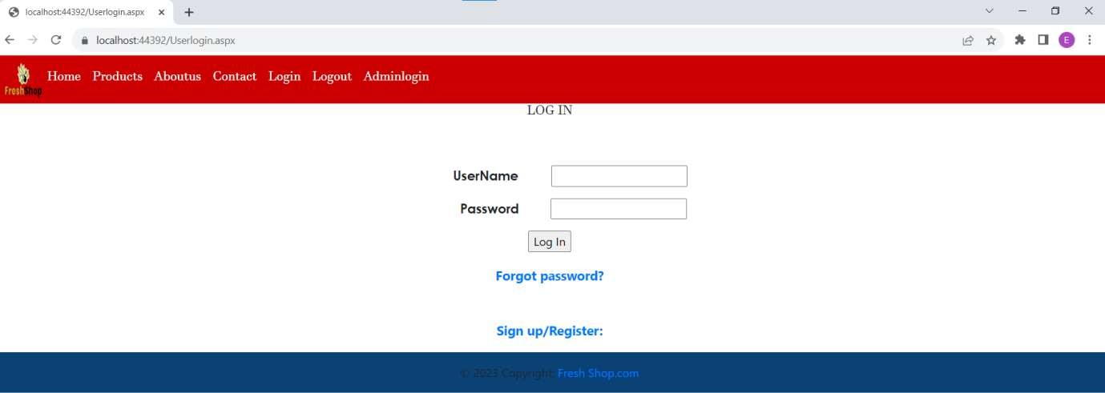

**User Product**

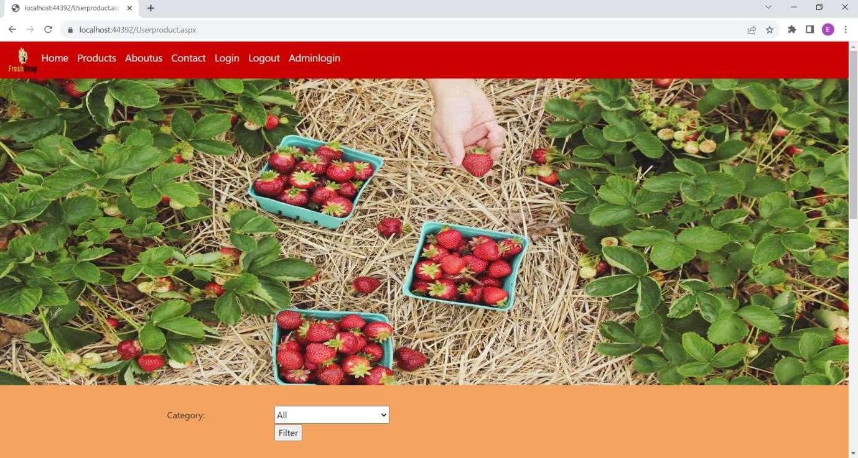

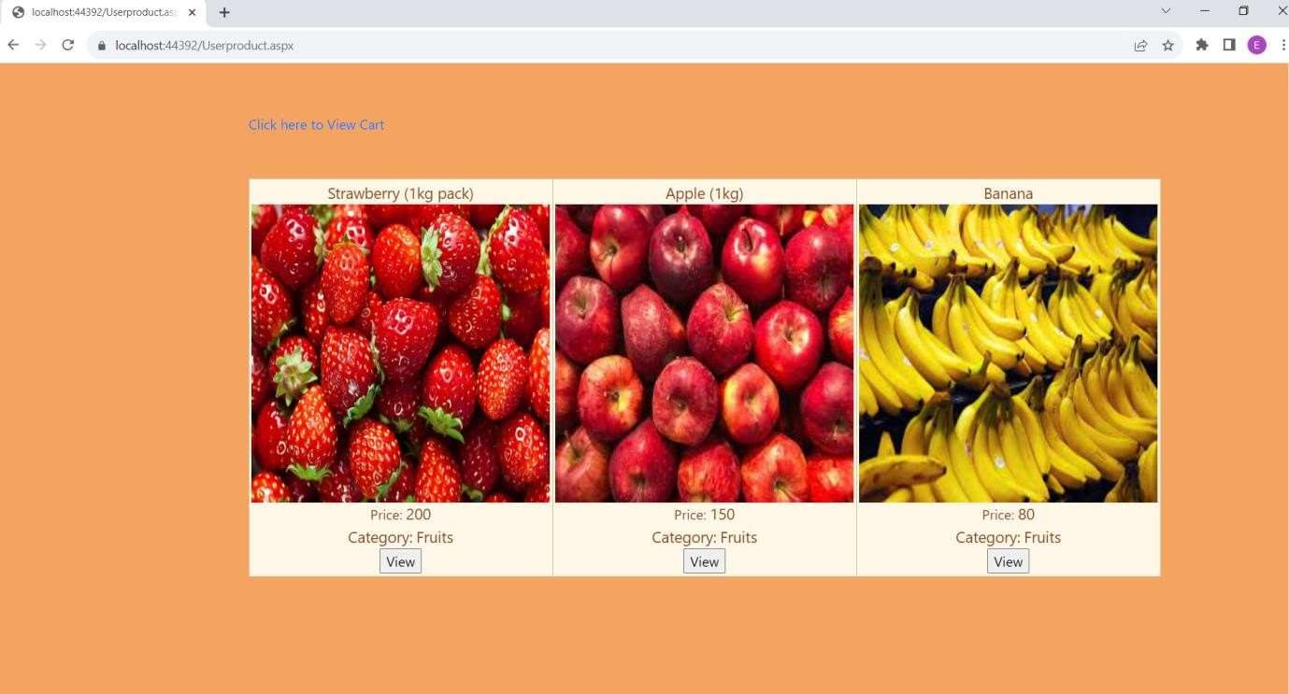

**After click on view**

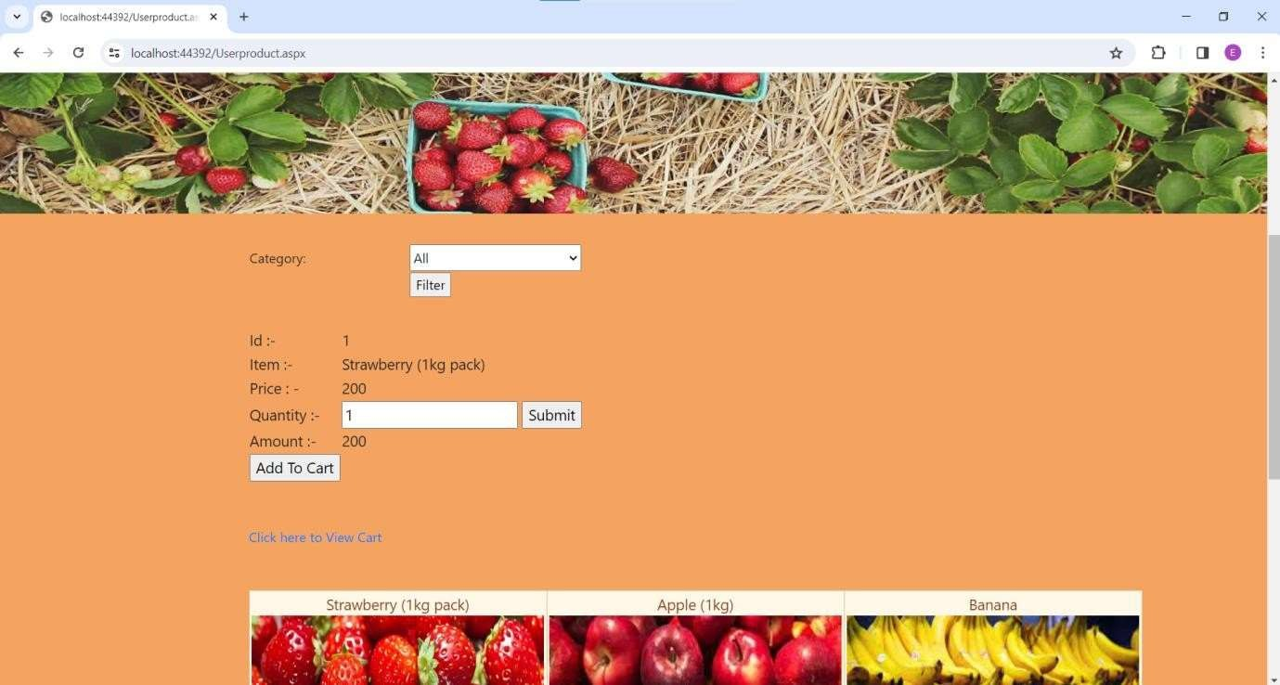

**View cart**

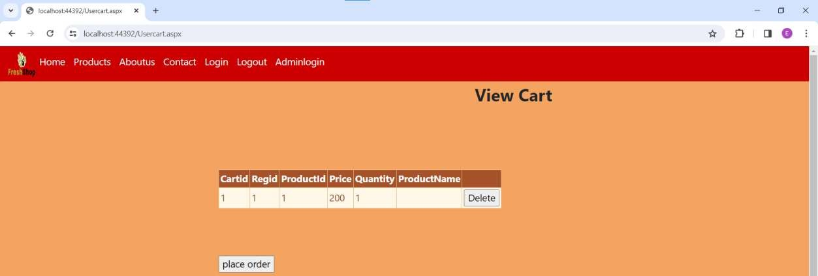

**Admin login**

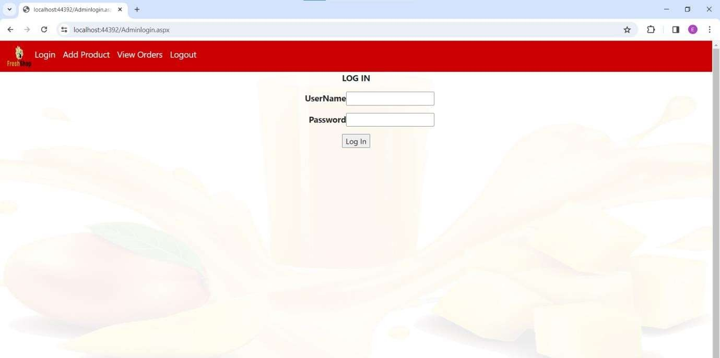

**Add product (add,update,delete,edit)**

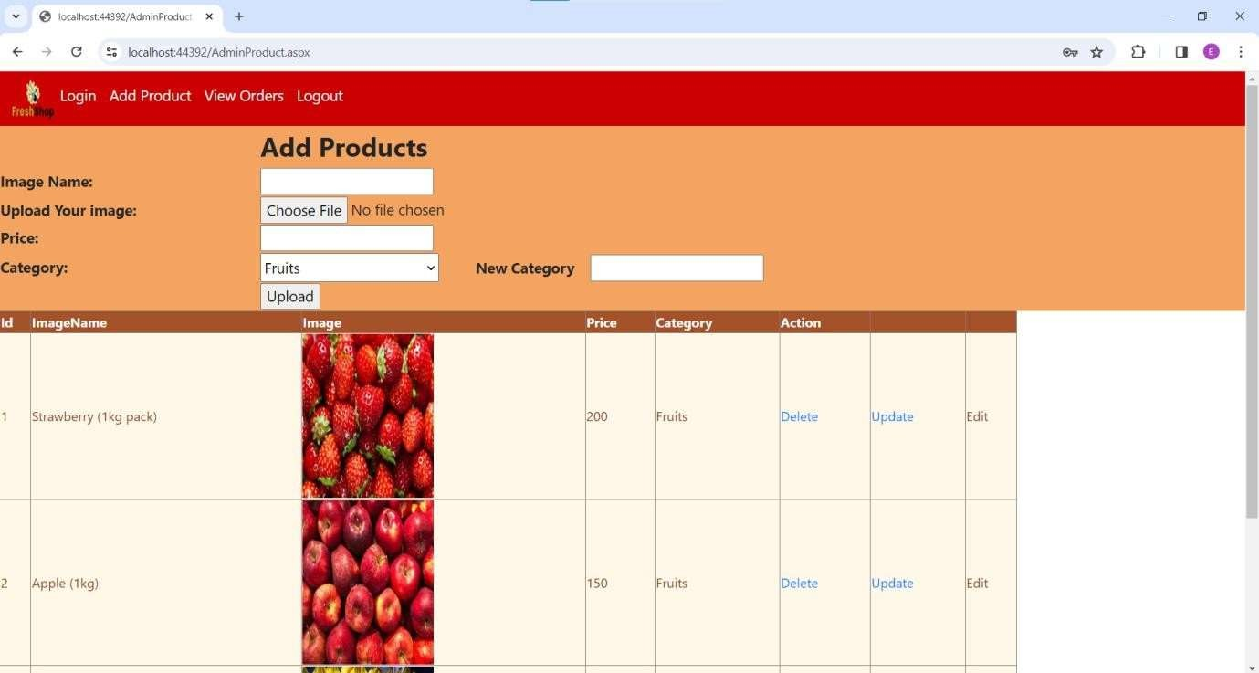

**SECURITY ISSUES**

#### Most common security issues are applicable for the project:

SQL Injection System Failure Power Cuts Hardware Failure

**Test Case Design:**

|  |  |  |  |  |  |  |
| --- | --- | --- | --- | --- | --- | --- |
| **Test Case For Registration Now** | | | | | | |
| **Test Case ID** | **Test Case** | **Test Condition** | **Steps to be executed** | **Expected Result** | **Actu al Resul**  **t** | **Pass/ Fail** |
| TC1 | New User Registration | Enter to the Web Page | 1. Click on the Web Site | Store Management open for accessing in functionality.   1. Student id(textbox) 2. Student Name(textbox) 3)Address(textbox)   4) Mobile No. (textbox) 5)Email(textbox)  6)Date Of Birth(textbox) 7)Gender(Radio buttons) 8)Course(Dropdown list)   1. Year Of Joining (textbox) 2. Year Of Pass Out (textbox) 3. Present Status(textbox) 4. Present Working Place(textbox) 5. User Name(textbox) 14)Password(textbox) 15)Confirm Password(textbox) 16)Submit(Button) 17)Cancel(Button) |  |  |
| TC2 | New User Registration | Enter to the Web Page | Try to Access Web Site | Registration Page |  |  |
| TC3 | New User  Registration | Enter to Web  page | Click on the Registration  Form | Open the Registration Form |  |  |
| TC4 | New User Registration | Tries to fill up Registration Form | 1. Generate Student Id 2. Enter Student Name 3. Enter Address 4. Enter Mobile No. 5. Enter Email 6. Enter Date Of Birth 7. Select Gender 8. Select Course 9. Enter Year Of Joining 10. Enter Year Of Pass Out 11. Enter Present Status 12. Enter Present Working Place 13. Enter User Name 14. Enter Password | Registration Successfully. |  |  |

|  |  |  |  |  |  |  |
| --- | --- | --- | --- | --- | --- | --- |
|  |  |  | 1. Retype Password 2. Click on Submit |  |  |  |
| TC5 | New User Registration | Try to access  cancel button functionality | Click on the Cancel Button | Cancel Successfully… |  |  |
| **Test Case For Sign In** | | | | | | |
| **Test Case ID** | **Test Case** | **Test Condition** | **Steps to be executed** | **Expected Result** | **Actu al**  **Resul t** | **Pass/ Fail** |
| TC1 | Try to access Web Site | Enter to the Web Page | 1. Click on the Web Site | Alumni Management Portal open for accessing in functionality.   1. User Name(textbox), 2. Email ID(textbox), 3)Password(password) 3. Forgot Password?(Link) 4. Sign In(Button) 5. Cancel(Button) |  |  |
| TC2 | User Login | Enter valid User Name & Password | 1. Enter User Name in Textbox 2. Enter Email ID in Textbox 3. Enter Password in password box 4. Click on Sign In Button | User Logged in as an User |  |  |
| TC3 | User Login Test | Enter invalid User Name & Password | 1. Enter User Name in Textbox 2. Enter Email ID in Textbox 3. Enter Password in password box 4. Click on Sign In Button | Web Page should display error message: "Please enter valid User Name & Password". |  |  |
| TC4 | User Login Test | Enter valid User Name & Invalid Password | 1. Enter User Name in Textbox 2. Enter Email ID in Textbox 3. Enter Password in password box 4. Click on Sign In Button | Web Page should display error message: "Please enter valid Password". |  |  |
| TC5 | User Login Test | Enter invalid User Name & valid Password | 1. Enter User Name in Textbox 2. Enter Email ID in Textbox 3. Enter Password in password box 4. Click on Sign In Button | Web Page should display error message: "Please enter valid User Name". |  |  |

### CONCLUSION

This project was actually a great opportunity for growth of myself and I enjoyed everysingle period of work. The task took more time to the different parts of the project development and gave its genuine understanding. The struggle and challenges faced by me during the project development was life learning and will always be our actual guide for future. I had put all my best to perform the project.

The project is running effectively and agreeably to satisfy the clients expectations. During the task advancement I truly understood the betterments and facilities those might havebeen given to upgrade the venture. I look at them as future improvements.

### BIBLIOGRAPHY

1. https://[www.c-sharpcorner.com](http://www.c-sharpcorner.com/)
2. https://[www.stackoverflow.com](http://www.stackoverflow.com/)
3. https://[www.w3school.com](http://www.w3school.com/)
4. https://[www.aspsnippets.com](http://www.aspsnippets.com/)
5. https://[www.codeproject.com](http://www.codeproject.com/)